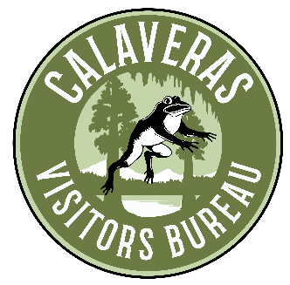

Board of Directors Meeting Minutes
April 22, 2022 3:00 pm
Via Zoom Video Conference & 753 S. Main St., Angels Camp, CA

The meeting was called to order at 3:04 AM by Sandra Hess. This meeting was held via Zoom Video Conferencing and in-person at the Angels Camp Museum.

Board Members Present: Linn Pillsbury, Mary Jane Genochio, , Kathy Gallino, Mark Silverstone, Sandra Hess, Jeremy Leonard, Betsy Uttley, Bill Babbis, Susan Weatherby, Sarah Lundsford, Kathy Collins

Absent Members: Krissy Haderer, Jeremy Leonard, Amber Sprock

CVB Staff Present: Martin Huberty, Jessica Johnson

1. Special items to be discussed:

A) Steve Collum Display Garden at the Calaveras County Fairgrounds – Sandra Hess requested the CVB donate $1,000 towards the CWA’s Memorial Vineyard to honor Steve Collum who played an integral part of the formation of the winegrape industry in Calaveras County. The CWA has received a bid for $3,400 for the sign package for the vineyard that includes QR codes for education of each of the eight varietals chosen with Steve Collum in mind. CWA will be responsible for all maintenance of the demo vineyard. Ironstone Vineyards and Chatom Vineyards have each donated $1,000 towards the memorial. Discussion: Martin H. read the mission statement of the CVB which includes the promotion of cultural and educational elements for visitors to Calaveras County. He believes that this donation would be in line with the CVB mission statement. Linn P. noted that as the CVB moves forward with donating to outside groups that donations stayed within the CVB mission. She suggested the CVB consider how it wants to look at the criteria for donations. Kathy G. said she believes the donation is in accordance with the CVB mission. Kathy Collins motioned for the CVB to donate $1,000 to the CWA designated for the Steve Collum Memorial Demo Vineyard. Mary Jane G. 2nd the motion. All were in favor. None opposed. Mark Silverstone and Sandra Hess abstained.

B) Purchase of little school bus – After researching the cost and maintenance of the school bus, Martin requested that this was no longer something the CVB should pursue purchasing. The attending CVB board members all agreed.

C) Bay Area Travel Tour – Bill Babbis and Sandra Hess did an amazing job of hosting the Bay Area Media journalists. Vine 18 had a coursed dinner and the CWA provided award winning wine pairings. On Friday, Morgan Gace of Gold Rush Touring Company provided transportation of the journalists from the Gateway Hotel in Copperopolis to Calaveras Big Trees, Hinterhaus, Ironstone Vineyards, Boyle-McDonald Tasting Room, the Murphys Historic Hotel, and back to Copperopolis. High-credentialed writers were in attendance, and Martin is looking forward to the ROI statistics and stories coming from the trip. He believes when other people are writing about the county it is more powerful than the county writing about itself.

Meeting adjourned at 3:29 pm.

